Dear Parents and Carers,
Thank you for supporting our fundraising activities this year. We are pleased to let you know how the money raised has been used to benefit our pupils.
The funds have been spent on:
• New PE and sports equipment
• Planters and plants to create an eco-area in our school grounds
These are projects that could not have been paid for through the school's normal budget, so your support has made a real difference.
The new sports equipment will help children take part in a wider range of activities during PE lessons, playtimes, and after-school clubs. Good-quality equipment helps pupils develop their physical skills, build confidence, learn to work as part of a team, and enjoy being active. Being active also supports children's health, wellbeing, and learning. Thanks to your contributions, the children now have access to new: Footballs, Agility Ladders, Hurdles, Bean bags, Netballs, Bibs, Rounders Bats, Rugby Balls, Javelins and Tennis balls.
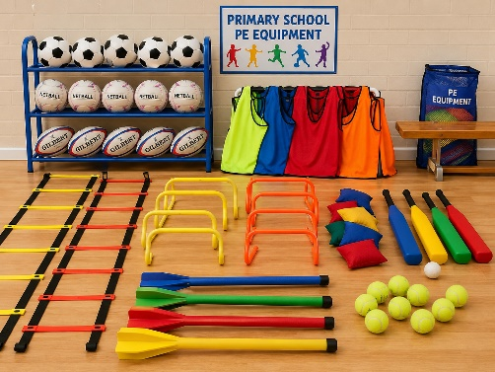
The new eco area will give pupils the chance to learn about plants, wildlife, and caring for the environment. Children will be able to take part in planting and looking after the area, helping them to develop responsibility and respect for nature. The eco area will also provide a calm and enjoyable outdoor space that supports learning and wellbeing.

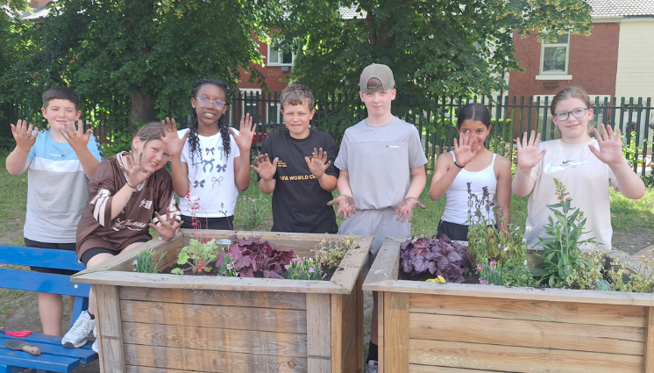 |  | 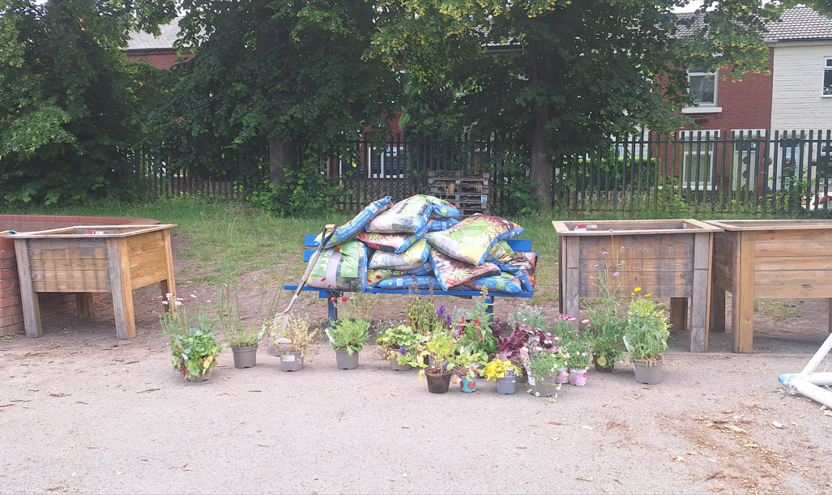
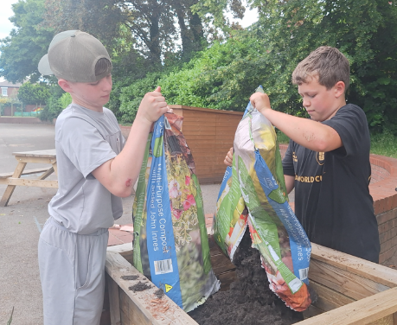 | 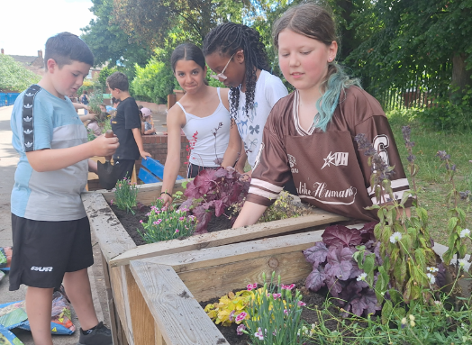 |  | 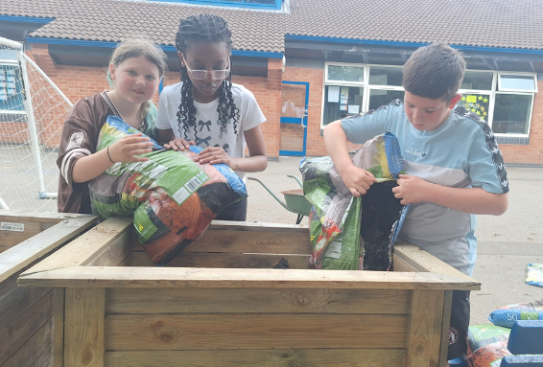

We are very grateful for the generosity of our families and wider school community. Thanks to your support, we have been able to provide opportunities that will enrich children's experiences and help them learn and grow.
Thank you once again for your continued support.
Yours sincerely,
C Walls

